White Box Testing

firebaseAuthwithGoogle()

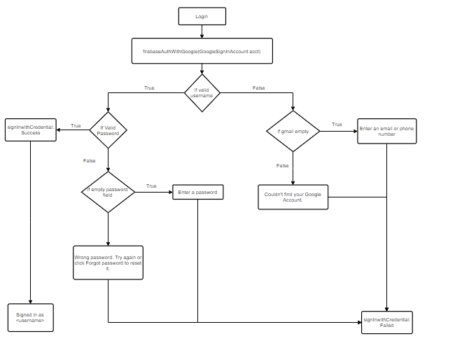

14

13

11

12

10

9

8

7

6

3

4

5

2

1

Cyclomatic Complexity :

CC(equation 2) = Decision points + 1

     = 4 + 1 = 5

5 Basis Paths

1. 1, 2, 3, 4, 5
2. 1, 2, 3, 6, 7, 10
3. 1, 2, 3, 6, 8, 9
4. 1, 2, 11, 13
5. 1, 2, 11, 12, 14

5 Test Cases

1. Logging in with Google Account with correct credentials
2. Logging in with correct google account username but left password field empty
3. Logging in with correct google account username but incorrect password.
4. Logging in with google account username empty.
5. Logging in with incorrect google account username.

5 Real Execution Paths.

1. 1, 2, 3, 4, 5
2. 1, 2, 3, 6, 7, 10
3. 1, 2, 3, 6, 8, 9
4. 1, 2, 11, 13
5. 1, 2, 11, 12, 14

FilterFlats()

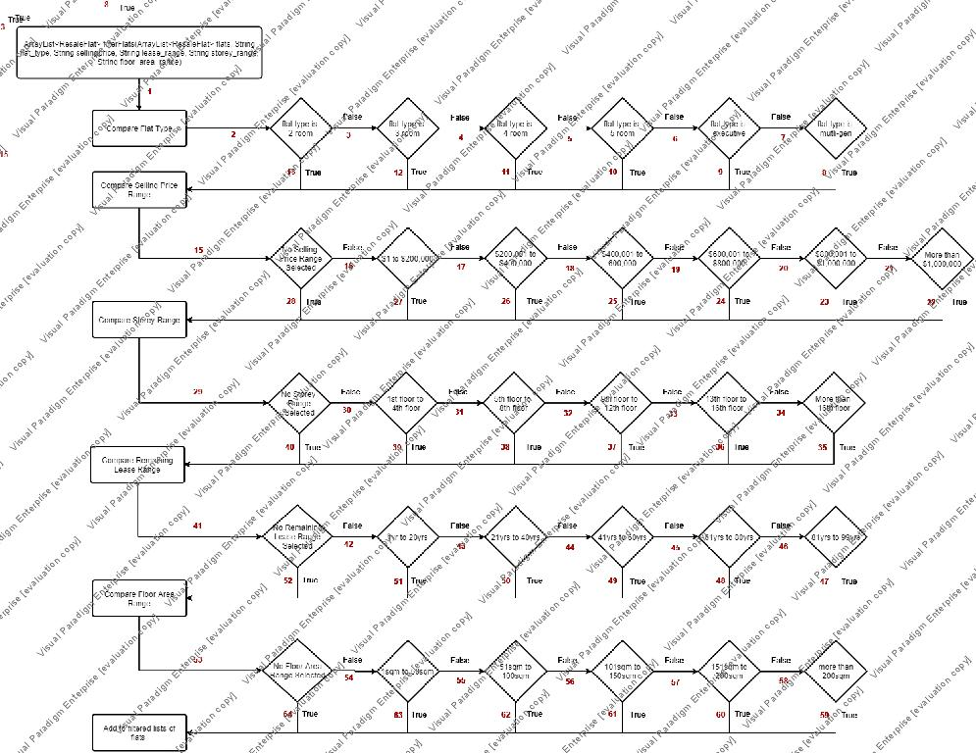

Cyclomatic Complexity :

CC(equation 2) = Decision points + 1

     = 31 + 1 = 32

32 Basis Paths

1. 1,2,13,15,28,29,40,41,52,53,64

…….

1. 1,2,3,4,5,6,7,8,15,16,17,18,19,20,21,22,29,30,31,32,33,34,35,41,42,43,44,45,46,47,53,54,55,56,57,58,59

32 Test Cases:

1. Flat Type: 2 Room Flat, No filters for remaining filter types

…….

1. Flat Type: Multi Generation, Selling Price Range>$1,000,000, Storey Range >16th Floor, Remaining Lease Range: 81 years to 99 years, Floor Area Range, more than 200sqm.